Regulations:
A14

H.T No

Sreenidhi Institute of Science and Technology
(An Autonomous Institution)
Code No: 4H214 Date: 24-May-2018 (FN)

B.Tech I-Year II-Semester End External Examination, May/June - 2018 (Supplementary)
Mathematics for Biotechnology - II (BT)

Time: 3 Hours Max.Marks:70

Note: a) No additional answer sheets will be provided.
b) All sub-parts of a question must be answered at one place only, otherwise it will not be valued.
c) Missing data can be assumed suitably.

Part - A Max.Marks:20

Answer all QUESTIONS.

1. | Mention the methods to solve first order and first degree ordinary differential equations | [2M]
2. | Find the Particular Integral of 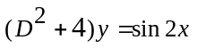 | [2M]
3. | Find the partial differential equation from the equation z =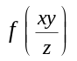 by eliminating arbitrary function. | [2M]
4. | Write the Fourier series expansion for the even function along with coefficients in the interval(-1,1) | [2M]
5. | State first shifting theorem in Laplace Transforms | [2M]
6. | Evaluate 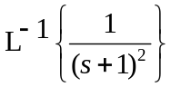 | [2M]
7. | Mention two applications of second order ordinary differential equations | [2M]
8. | Solve xp+yq=z | [2M]
9. | What is Laplace Transform of unit step function? | [2M]
10. | Find the integration factor of the differential equation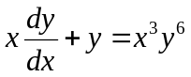 | [2M]
Part – B Max.Marks:50
ANSWER ANY FIVE QUESTIONS. EACH QUESTION CARRIES 10 MARKS.

11. | a) | Solve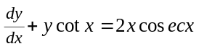 | [5M]
 | b) | It is observed that Water at temperature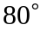 cools in 10 minutes to 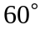 in a room temperature of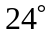.Find the temperature of water after 20 minutes. | [5M]
12. |  | Solve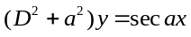 by using the method of variation of parameters | [10M]
13. | a) | Solve 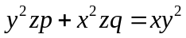 | [5M]
 | b) | Solve 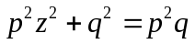 | [5M]
14. |  | Find the Fourier series of the function f(x)=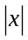 in the interval 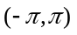 and hence deduce 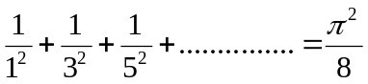 | [10M]
15. | a) | Find the Laplace transform of f(t)= t²cos4t | [5M]
 | b) | Evaluate 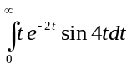 | [5M]
16. |  | Evaluate L⁻¹ 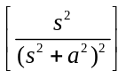 using convolution theorem | [10M]
17. | a) | Solve 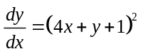. | [5M]
 | b) | Solve 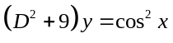 | [5M]
18. |  | Using Laplace Transforms solve 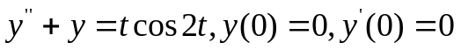 | [10M]

-- 00 -- 00 –

